![Ironhack Logo](https://i.imgur.com/1QgrNNw.png)

# Answers

### 1. All the companies that it's name match 'Babelgum'. Retrieve only their `name` field.

FILTER{name:{$eq: "Babelgum"}}
PROJECT {name : 1, _id:0}

### 2. All the companies that have more than 5000 employees. Limit the search to 20 companies and sort them by **number of employees**.

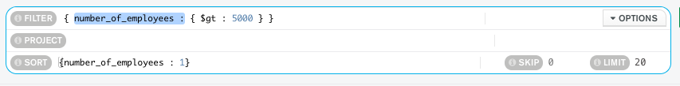

### 3. All the companies founded between 2000 and 2005, both years included. Retrieve only the `name` and `founded_year` fileds.

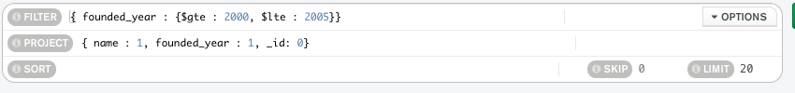

### 4. All the companies that had an IPO of more than 100.000.000 and have been founded before 2010. Retrieve only the `name` and `ipo` fields.
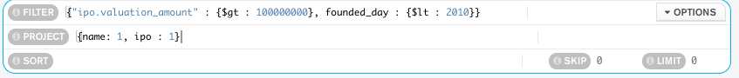

### 5. All the companies that have less than 1000 employees and have been founded before 2005. Order them by the number of employees and limit the search to 10 companies.

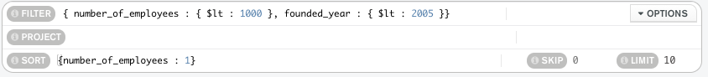

### 6. All the companies that don't include the `partners` field.
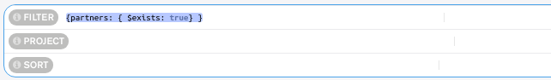

### 7. All the companies that have a null type of value on the `category_code` field.
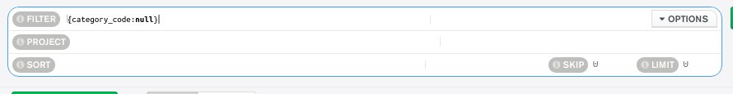

### 8. All the companies that have at least 100 employees but less than 1000. Retrieve only the `name` and `number of employees` fields.

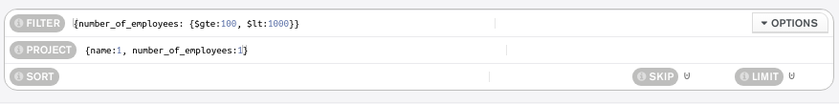

### 9. Order all the companies by their IPO price descendently.

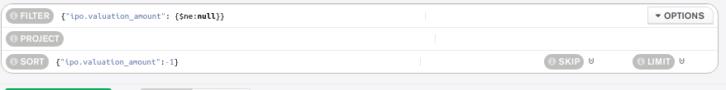

### 10. Retrieve the 10 companies with more employees, order by the `number of employees`

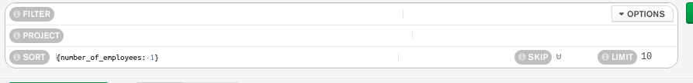

### 11. All the companies founded on the second semester of the year. Limit your search to 1000 companies.
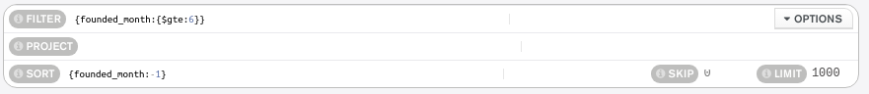

### 12. All the companies that have been 'deadpooled' after the third year.

### 13. All the companies founded before 2000 and that have acquisition amount of more than 10.000.000
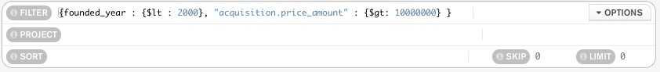

### 14. All the companies that have been acquired after 2015, order by the acquisition amount, and retrieve only their `name` and `acquisiton` field.
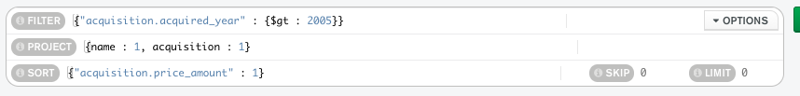

### 15. Order the companies by their `founded year`, retrieving only their `name` and `founded year`.
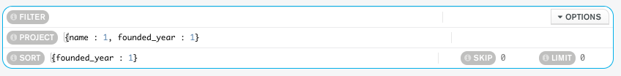

### 16. All the companies that have been founded on the first seven days of the month, including the seventh. Sort them by their `aquisition price` descendently. Limit the search to 10 documents.
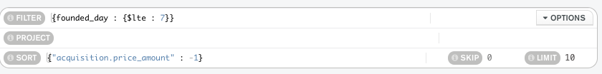

### 17. All the companies on the 'web' `category` that have more than 4000 employees. Sort them by the amount of employees in ascendant order.

### 18. All the companies which their acquisition amount is more than 10.000.000, and currency are 'EUR'.

### 19. All the companies that have been acquired on the first trimester of the year. Limit the search to 10 companies, and retrieve only their `name` and `acquisition` fields.

### 20. All the companies that have been founded between 2000 and 2010, but have not been acquired before 2011.

